Irregular Pentagonal Pyramid
# Source: AI Source: Provided by: [Data Path: Persons Table -> ID Column: 1, Name_En Column: Motasem Essam] -> From: [ChatGPT] on [7/25/2026]
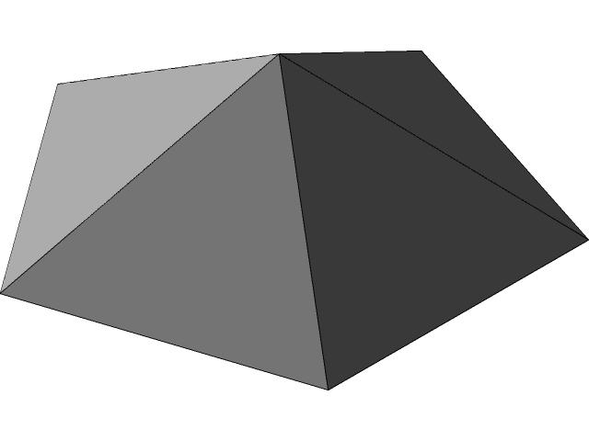

Definition
# Source: AI Source: Provided by: [Data Path: Persons Table -> ID Column: 1, Name_En Column: Motasem Essam] -> From: [ChatGPT] on [7/25/2026]
An irregular pentagonal pyramid is a three-dimensional geometric solid whose base is an irregular pentagon and whose five triangular lateral faces meet at a single point called the apex.
An irregular pentagon is a five-sided polygon whose sides or interior angles are not all equal. Its five sides may have different lengths, and its five interior angles may have different measures.
An irregular pentagonal pyramid has:
- 1 irregular pentagonal base.
- 5 triangular lateral faces.
- 6 faces in total.
- 10 edges in total.
- 6 vertices in total.
The pyramid may be right or oblique, depending on the position of the apex relative to the designated center of the base. Because the base is irregular, its center must be defined carefully.

Simple Definition
# Source: AI Source: Provided by: [Data Path: Persons Table -> ID Column: 1, Name_En Column: Motasem Essam] -> From: [ChatGPT] on [7/25/2026]
An irregular pentagonal pyramid is a pyramid with an irregular five-sided base and five triangular sides that meet at one apex.

Geometric Representation
# Source: AI Source: Provided by: [Data Path: Persons Table -> ID Column: 1, Name_En Column: Motasem Essam] -> From: [ChatGPT] on [7/25/2026]
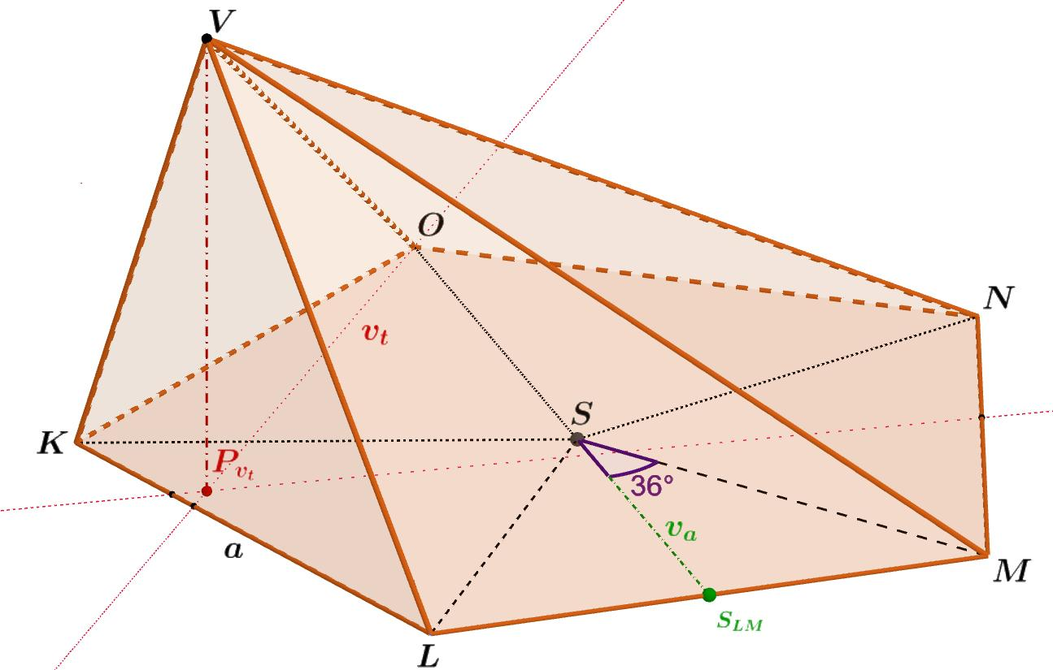
The main components are:
- Base: An irregular pentagon with five sides and five vertices.
- Apex: The point where the five lateral faces meet.
- Base edges: The five sides of the irregular pentagon.
- Lateral edges: Five line segments joining the apex to the five base vertices.
- Lateral faces: Five triangles connecting the apex to the five base edges.
- Height: The perpendicular distance from the apex to the plane containing the base.
- Slant height of a face: The perpendicular altitude of an individual triangular lateral face.
Unlike a regular pentagonal pyramid, an irregular pentagonal pyramid generally does not have five congruent lateral faces. The shape of each triangle depends on the corresponding base edge and the location of the apex.

Mathematical Representations and Formulas
# Source: AI Source: Provided by: [Data Path: Persons Table -> ID Column: 1, Name_En Column: Motasem Essam] -> From: [ChatGPT] on [7/25/2026]
Let:
- $B$ = area of the irregular pentagonal base.
- $H$ = perpendicular height of the pyramid.
- $P$ = perimeter of the base.
- $A_{L}$ = lateral surface area.
- $A_{T}$ = total surface area.
- $s_{i}$ = length of the $i$-th base edge.
- $l_{i}$ = perpendicular altitude of the corresponding triangular face.

Base Perimeter
# Source: AI Source: Provided by: [Data Path: Persons Table -> ID Column: 1, Name_En Column: Motasem Essam] -> From: [ChatGPT] on [7/25/2026]
The perimeter is the sum of the five base-edge lengths:
$$\boxed{P=s_{1}+s_{2}+s_{3}+s_{4}+s_{5}}$$
Because the pentagon is irregular, the five side lengths do not all have to be equal.

Base Area
# Source: AI Source: Provided by: [Data Path: Persons Table -> ID Column: 1, Name_En Column: Motasem Essam] -> From: [ChatGPT] on [7/25/2026]
There is no single regular-pentagon area formula that applies to every irregular pentagon using only one side length.
Instead, the base area can be calculated by dividing the pentagon into triangles or other simpler shapes and adding their areas.
For a triangle with base $b_{i}$ and perpendicular altitude $h_{i}$:
$$A_{i}=\frac{1}{2}b_{i}h_{i}$$
If the pentagon is divided into three non-overlapping triangles:
$$\boxed{B=A_{1}+A_{2}+A_{3}}$$
This method works when the chosen diagonals divide the pentagon into three triangles without overlap.

Volume
# Source: AI Source: Provided by: [Data Path: Persons Table -> ID Column: 1, Name_En Column: Motasem Essam] -> From: [ChatGPT] on [7/25/2026]
The volume of any pyramid is one-third of its base area multiplied by its perpendicular height:
$$\boxed{V=\frac{1}{3}BH}$$
This formula applies whether the base is regular or irregular and whether the pyramid is right or oblique.

Lateral Surface Area
# Source: AI Source: Provided by: [Data Path: Persons Table -> ID Column: 1, Name_En Column: Motasem Essam] -> From: [ChatGPT] on [7/25/2026]
The lateral surface area is the sum of the areas of the five triangular faces:
$$A_{L}=A_{1}+A_{2}+A_{3}+A_{4}+A_{5}$$
For each triangular face:
$$A_{i}=\frac{1}{2}s_{i}l_{i}$$
Therefore:
$$\boxed{A_{L}=\frac{1}{2}\sum_{i=1}^{5}{s_{i}}l_{i}}$$
The formula
$$A_{L}=\frac{1}{2}Pl$$
is valid only when a common slant height $l$ applies to all five faces, as in a regular right pentagonal pyramid. It should not generally be used for an irregular pentagonal pyramid.

Total Surface Area
# Source: AI Source: Provided by: [Data Path: Persons Table -> ID Column: 1, Name_En Column: Motasem Essam] -> From: [ChatGPT] on [7/25/2026]
The total surface area includes the base and all five lateral faces:
$$\boxed{A_{T}=B+A_{L}}$$

Euler’s Formula
# Source: AI Source: Provided by: [Data Path: Persons Table -> ID Column: 1, Name_En Column: Motasem Essam] -> From: [ChatGPT] on [7/25/2026]
For a convex irregular pentagonal pyramid:
$$V_{e}-E+F=2$$
Substituting the numbers of vertices, edges, and faces:
$$6-10+6=2$$
Therefore, the solid satisfies Euler’s formula for convex polyhedra.

Worked Examples
# Source: AI Source: Provided by: [Data Path: Persons Table -> ID Column: 1, Name_En Column: Motasem Essam] -> From: [ChatGPT] on [7/25/2026]
Example 1: Finding the Base Perimeter
An irregular pentagonal base has side lengths of $4\text{ cm}$, $6\text{ cm}$, $5\text{ cm}$, $7\text{ cm}$, and $8\text{ cm}$. Find its perimeter.
Using:
$$P=s_{1}+s_{2}+s_{3}+s_{4}+s_{5}$$
$$P=4+6+5+7+8$$
$$\boxed{P=30\text{ cm}}$$
Example 2: Finding the Volume
An irregular pentagonal pyramid has a base area of $42{\text{ cm}}^{2}$ and a perpendicular height of $9\text{ cm}$. Find its volume.
Using:
$$V=\frac{1}{3}BH$$
$$V=\frac{1}{3}\left(42\right)\left(9\right)$$
$$\boxed{V=126{\text{ cm}}^{3}}$$
Example 3: Finding the Lateral Surface Area
The five triangular faces of an irregular pentagonal pyramid have areas of $8{\text{ cm}}^{2}$, $12{\text{ cm}}^{2}$, $10{\text{ cm}}^{2}$, $15{\text{ cm}}^{2}$, and $9{\text{ cm}}^{2}$. Find its lateral surface area.
$$A_{L}=8+12+10+15+9$$
$$\boxed{A_{L}=54{\text{ cm}}^{2}}$$
Example 4: Finding the Total Surface Area
The pyramid in Example 3 has a base area of $42{\text{ cm}}^{2}$. Find its total surface area.
$$A_{T}=B+A_{L}$$
$$A_{T}=42+54$$
$$\boxed{A_{T}=96{\text{ cm}}^{2}}$$
Example 5: Counting Faces, Edges, and Vertices
A pentagonal pyramid has a five-sided base, so $n=5$.
For a pyramid with an $n$-sided base:
$$F=n+1, E=2n, V_{e}=n+1$$
Therefore:
$$F=6, E=10, V_{e}=6$$
Answer: 6 faces, 10 edges, and 6 vertices.

Comparison with Related Pyramids
# Source: AI Source: Provided by: [Data Path: Persons Table -> ID Column: 1, Name_En Column: Motasem Essam] -> From: [ChatGPT] on [7/25/2026]
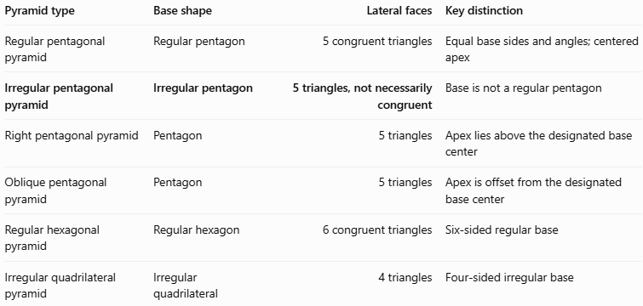
Pyramid type | Base shape | Lateral faces | Key distinction
Regular pentagonal pyramid | Regular pentagon | 5 congruent triangles | Equal base sides and angles; centered apex
Irregular pentagonal pyramid | Irregular pentagon | 5 triangles, not necessarily congruent | Base is not a regular pentagon
Right pentagonal pyramid | Pentagon | 5 triangles | Apex lies above the designated base center
Oblique pentagonal pyramid | Pentagon | 5 triangles | Apex is offset from the designated base center
Regular hexagonal pyramid | Regular hexagon | 6 congruent triangles | Six-sided regular base
Irregular quadrilateral pyramid | Irregular quadrilateral | 4 triangles | Four-sided irregular base
Important distinction: Irregular describes the base shape in this classification. It does not automatically mean that the pyramid is oblique. An irregular pentagonal pyramid can be right or oblique, depending on the apex's position and the convention used to define the base center.

Applications
# Source: AI Source: Provided by: [Data Path: Persons Table -> ID Column: 1, Name_En Column: Motasem Essam] -> From: [ChatGPT] on [7/25/2026]
Irregular pentagonal pyramids can be useful in:
- Architecture: Modeling asymmetrical roofs and structures with five-sided footprints.
- Engineering: Representing tapered components with nonuniform base dimensions.
- 3D modeling: Creating custom polyhedral shapes in CAD and computer graphics.
- Geometry education: Exploring irregular polygons, triangular face areas, and three-dimensional measurements.
- Surface-area calculations: Demonstrating how to calculate a solid's area when its lateral faces are not congruent.

Key Points
# Source: AI Source: Provided by: [Data Path: Persons Table -> ID Column: 1, Name_En Column: Motasem Essam] -> From: [ChatGPT] on [7/25/2026]
- An irregular pentagonal pyramid has an irregular five-sided base.
- It has 6 faces, 10 edges, and 6 vertices.
- Its five lateral faces are triangles that need not be congruent.
- Its base perimeter is the sum of its five side lengths.
- Its base area can be found by decomposing the pentagon into simpler shapes.
- Its volume is $V=\frac{1}{3}BH$.
- Its lateral surface area is the sum of the five triangular face areas.
- Its total surface area is $A_{T}=B+A_{L}$.
- It can be right or oblique; base irregularity and apex orientation are separate classifications.

Conclusion
# Source: AI Source: Provided by: [Data Path: Persons Table -> ID Column: 1, Name_En Column: Motasem Essam] -> From: [ChatGPT] on [7/25/2026]
An irregular pentagonal pyramid is a three-dimensional polyhedron with an irregular pentagonal base and five triangular lateral faces meeting at an apex. It has six faces, ten edges, and six vertices, just like a regular pentagonal pyramid.
Its defining difference is the irregularity of its base, which means that the side lengths or interior angles are not all equal. Its volume is calculated using the standard pyramid formula, while its lateral surface area is obtained by adding the areas of the five triangular faces individually. This makes it a useful example for understanding how general pyramid formulas apply even when the base and lateral faces lack regularity.

